1. Consider three processes (process id 0, 1, 2 respectively) with compute time bursts 2, 4 and 8 time units. All processes arrive at time zero. Consider the longest remaining time first (LRTF) scheduling algorithm. In LRTF ties are broken by giving priority to the process with the lowest process id. The average turn around time is:

(a) 13 units (b) 14 units            (c) 15 units (d) 16 units

1. Consider the set of 6 processes whose arrival time and burst time are given below-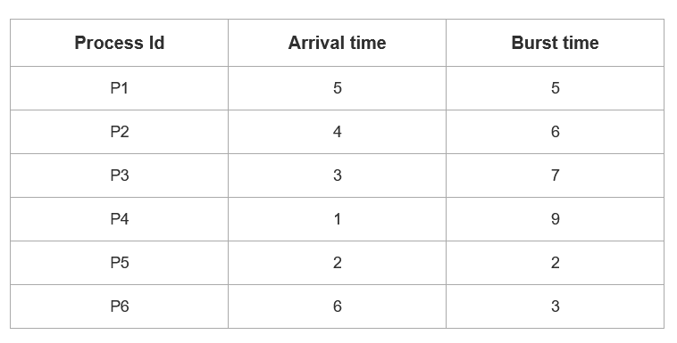

If the CPU scheduling policy is Round Robin with time quantum = 3, calculate the average waiting time and average turn around time.

1. An operating system uses shortest remaining time first scheduling algorithm for pre-emptive scheduling of processes. Consider the following set of processes with their arrival times and CPU burst times (in milliseconds):

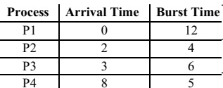

The average waiting time (in milliseconds) of the processes is ______.

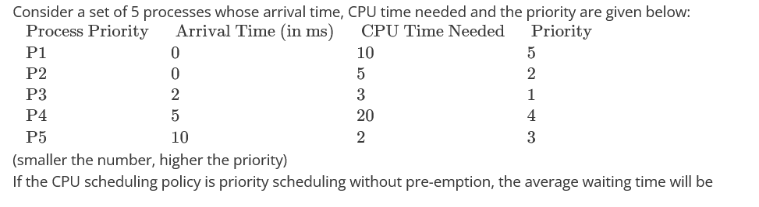

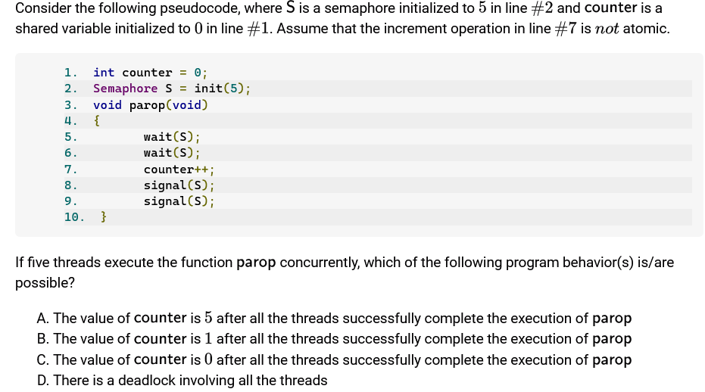

Q6 At a particular time the value of counting semaphore is 10. It will become 7 after:

3 V operations

3 P operations

5 V operations and 2 P operations

2 V operations and 5 P operations